# **Use Case Diagram**

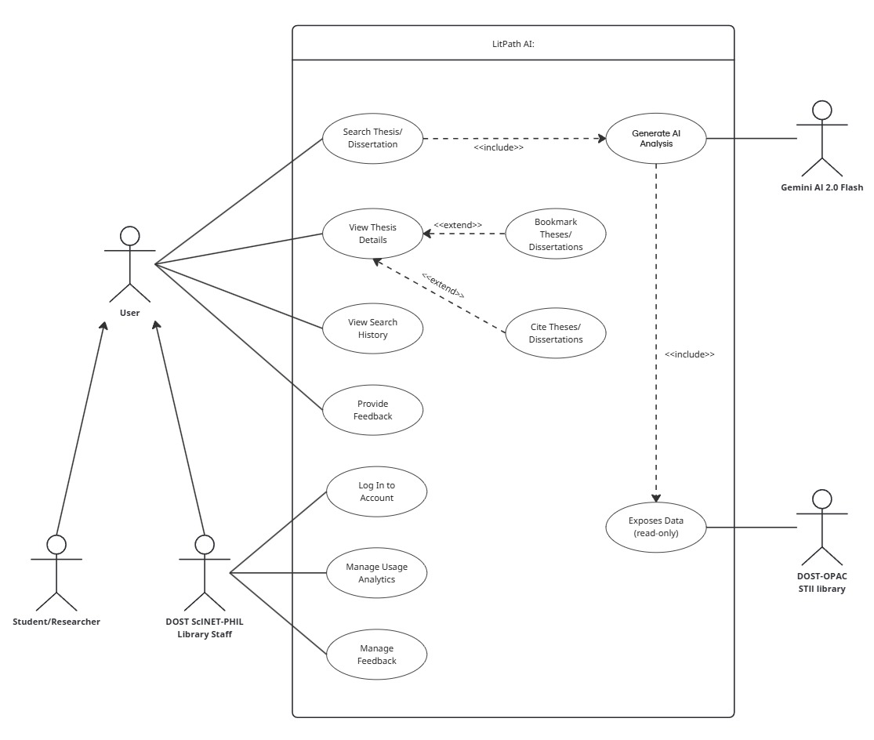

Figure 1 Use Case Diagram

## **Business Requirements (BR) or Product Requirements (PR)**

Table 1. List of Requirements

|  |  |  |
| --- | --- | --- |
| **ID** | **Requirement** |  |
| BR-01 | The system shall allow a Student/Researcher to submit natural language research questions to find relevant academic materials. |  |
| BR-02 | The system shall provide an AI-generated, ranked list of the top 10 relevant theses/dissertations and a summary overview based on the user's query. |  |
| BR-03 | The system shall allow a Student/Researcher to view detailed information for a selected document, including its abstract and metadata. |  |
| BR-04 | The system shall allow a Student/Researcher to save (bookmark) documents for future reference and remove them. |  |
| BR-05 | The system shall allow a Student/Researcher to generate academic citations for a document in various formats (APA, MLA, Chicago, IEEE). |  |
| BR-06 | The system shall allow a Student/Researcher to provide feedback on the quality of the AI-generated search results. |  |
| BR-07 | The system shall allow a Student/Researcher to view, resume, or delete sessions from their search history. |  |
| BR-08 | The system shall retrieve document data by executing read-only queries against the external DOST-OPAC STII Library. |  |
| BR-09 | The system shall allow Library Staff to securely log into an administrative dashboard using their existing DOST OPAC credentials. |  |
| BR-10 | The system shall provide an analytics dashboard for Library Staff to view and filter usage statistics, such as popular topics and frequently cited documents. |  |
| BR-11 | The system shall allow Library Staff to view, filter, and manage user-submitted feedback. |  |

## **Use Case Full Description**

Table 2. Use Case Name: Search Thesis/Dissertation

|  |  |
| --- | --- |
| Use Case ID | UC-01 |
| Author/s | Jenine Elaine Dulay, Charijoy Cempron |
| Purpose | To allow a user to enter a research question and receive a curated list of relevant theses and dissertations analyzed by an AI. |
| Requirement Traceability | BR-01, BR-02 |
| Priority | High |
| Preconditions | * The system is online and accessible. * User can access LitPath AI platform. |
| Postconditions | * On success, the user is presented with a ranked list of relevant documents and an AI-generated overview. * On failure, the user is notified of the issue (e.g., no results, system error). |
| Actors | Student/Researcher |
| Flow of Actions | **Basic Flow**   1. User accesses the “LitPath AI” search page. 2. User clicks search bar or "Start a new chat" and enters a research question into the search bar. 3. User clicks the search button to submit the query. 4. System retrieves relevant document data from the DOST-OPAC STII Library. 5. System sends the document data and the user's query to the Gemini AI for analysis. 6. System receives a ranked list of documents and a generated overview from the AI. 7. System displays the ranked search results and the AI-generated overview to the user.   **Alternative Flow**  **A1**: User Applies Filters  This can occur before or after step 3 of the Basic Flow.   1. User applies filters (ex. by discipline or publication date). 2. System constrains the data retrieval in step 4 based on the applied filters. 3. Use case continues from step 5 of the Basic Flow with the filtered dataset.   **A2**: AI Provides Clarifying Suggestions for Vague Query  This occurs if the system detects a vague or broad query at step 5 of the Basic Flow.   1. The AI engine identifies the query as ambiguous. 2. Instead of a ranked list, the system presents the user with clarifying questions or suggested, more specific research topics. 3. The user selects one of the suggestions or manually refines their original query. 4. The use case restarts from step 3 of the Basic Flow with the new, refined query.   **Exception Flows**  **E1**: No Results Found  This occurs if the system, after step 4 of the Basic Flow, finds no matching documents in the library.   1. System displays a message to the user indicating that no relevant documents were found. 2. System may provide tips on how to broaden the search query. 3. Use case ends.   **E2**: System Timeout or AI Service Error  This can occur at step 5 or 6 of the Basic Flow if the connection to the Gemini AI fails or times out.   1. System detects the error. 2. System displays an error message to the user, such as "We're sorry, the AI service is currently unavailable. Please try again later." 3. Use case ends. |

Table 3. Use Case Name: View Thesis Details

|  |  |
| --- | --- |
| Use Case ID | UC-02 |
| Author/s | Jenine Elaine Dulay |
| Purpose | To allow users to view comprehensive details of a selected thesis or dissertation. |
| Requirement Traceability | BR-03 |
| Priority | High |
| Preconditions | * User is on the search results page. * System is online |
| Postconditions | * On success, the user is shown detailed information for the selected document. * User's viewing activity is logged for analytics. |
| Actors | Student/Researcher |
| Flow of Actions | **Basic Flow**   1. From the search results list, the user clicks on the title of a thesis or dissertation they wish to view. 2. System retrieves the detailed record for the selected document. 3. System displays the document's details, including the title, author, publication year, abstract, disciplines, and library location. 4. System logs the viewing of this document to the usage statistics.   **Alternative Flows (Extensions)**  **A1:** User bookmarks the document   * Condition: At any point after step 3 of the Basic Flow, the user clicks the "Bookmark" button. * Action: The flow of the UC-03: Bookmark Theses/Dissertations use case is executed.   **A2:** User generates a citation   * Condition: At any point after step 3 of the Basic Flow, the user clicks the "Cite" button. * Action: The flow of the UC-04: Cite Theses/Dissertations use case is executed.   **Exception Flows**  **E1:** Document details are unavailable  This occurs if the system at step 2 of the Basic Flow cannot retrieve the selected record.   1. System displays an error message, such as "Sorry, the details for this document could not be retrieved at this time." 2. Use case ends. |

Table 4. Use Case Name: Bookmark Theses/Dissertations

|  |  |
| --- | --- |
| Use Case ID | UC-03 |
| Author/s | Jenine Elaine Dulay |
| Purpose | To allow users to save a specific thesis or dissertation for future reference. |
| Requirement Traceability | BR-04 |
| Priority | High |
| Preconditions | * User is viewing the detailed information of a specific document (UC-02: View Thesis Details is active). * System is online |
| Postconditions | * On success, the selected document is added to the user's bookmark list, and the user is notified. * The bookmarking action is logged for analytics. |
| Actors | Student/Researcher |
| Flow of Actions | **Basic Flow**   1. While viewing the details of a document, the user clicks the "Bookmark" icon. 2. System saves item to bookmarks and appears in "Saved Items" section. 3. System displays a confirmation message to the user, such as "Bookmark added." 4. System logs the bookmarking action for analytics.   **Alternative Flow**  **A1:** User removes an existing bookmark  **Condition:** The user clicks the "Bookmark" icon for a document that is already bookmarked.   1. System removes the document's reference from the user's bookmark list. 2. System displays a confirmation message, such as "Bookmark removed." 3. Use case ends.   **Exception Flows**  **E1:** System fails to save the bookmark  **Condition:** This occurs at step 2 of the Basic Flow if the system cannot write to the bookmarks data store.   1. System detects the save error. 2. System displays an error message to the user, such as "Sorry, the bookmark could not be saved at this time." 3. Use case ends. |

Table 5. Use Case Name: Cite Theses/Dissertations

|  |  |
| --- | --- |
| Use Case ID | UC-04 |
| Author/s | Jenine Elaine Dulay |
| Purpose | To allow users to generate a formatted citation for a specific document. |
| Requirement Traceability | BR-05 |
| Priority | High |
| Preconditions | * User is viewing the detailed information of a specific document (UC-02: View Thesis Details is active). * System is online |
| Postconditions | * On success, a formatted citation is displayed to the user. * Citation action is logged for analytics. |
| Actors | Student/Researcher |
| Flow of Actions | **Basic Flow**   1. While viewing the details of a document, the user clicks the "Cite" icon. 2. System displays a list of available citation formats (APA, MLA, Chicago, IEEE) 3. Choose citation format. 4. System generates and displays the citation in the default format. 5. System provides an option for the user to copy the citation to their clipboard. 6. System logs citation action for analytics.   **Alternative Flow**  **A1:** User changes citation format  **Condition:** At step 3 of the Basic Flow, the user selects a different citation format from the list.   1. System regenerates and displays the citation in the newly selected format. 2. Use case resumes at step 5 of the Basic Flow.   **Exception Flows**  **E1:** System fails to generate the citation  **Condition:** This occurs at step 3 of the Basic Flow if the document's metadata is incomplete or corrupted.   1. System detects the error. 2. System displays an error message to the user, such as "Sorry, a citation could not be generated for this document due to missing information." 3. Use case ends. |

Table 6. Use Case Name: Provide Feedback

|  |  |
| --- | --- |
| Use Case ID | UC-05 |
| Author/s | Tracie Tomon |
| Purpose | To allow users to rate the quality of the AI-generated results and provide optional text feedback. |
| Requirement Traceability | BR-06 |
| Priority | High |
| Preconditions | * User is viewing a set of search results generated by the AI (UC-01 has been completed). * System is online |
| Postconditions | * On success, the user's feedback is saved to the feedback log. * User receives a confirmation that their feedback was submitted. |
| Actors | Student/Researcher |
| Flow of Actions | **Basic Flow**   1. After viewing the AI-generated search results, the user decides to provide feedback. 2. Rating interface appears. 3. User clicks on a star rating (1-5). 4. User enters text comments into the feedback field. 5. User clicks the "Submit Feedback" button. 6. System displays a confirmation message to the user, such as "Thank you for your feedback!" 7. System saves the rating and text comments to the D4: Feedback Log data store for admin review.   **Alternative Flows**  **A1:** User provides a rating but no text feedback  **Condition:** At step 3 of the Basic Flow, the user gives a rating but leaves the text field empty.   1. User clicks the "Submit Feedback" button. 2. Use case continues from step 6 of the Basic Flow. 3. System saves just the rating to the D4: Feedback Log data store for admin review.   **Exception Flows**  **E1:** System fails to save feedback  **Condition:** This occurs at step 5 of the Basic Flow if the system cannot write to the feedback data store.   1. System detects the save error. 2. System displays an error message to the user, such as "Sorry, your feedback could not be submitted at this time." 3. Use case ends. |

Table 7. Use Case Name: View Search History

|  |  |
| --- | --- |
| Use Case ID | UC-06 |
| Author/s | Tracie Tomon |
| Purpose | To allow users to access and resume their previous search sessions. |
| Requirement Traceability | BR-07 |
| Priority | High |
| Preconditions | * User has previously conducted at least one search. * System is online |
| Postconditions | * On success, the user is shown the details of a selected previous search session. |
| Actors | Student/Researcher |
| Flow of Actions | **Basic Flow**   1. User clicks on the "Research History" link or button. 2. System retrieves and displays a list of the user's previous search sessions. 3. User selects a specific session from the list to view. 4. System retrieves the full context for the selected session, including the original query and the AI-generated results. 5. System displays the selected search session, allowing the user to continue the interaction.   **Alternative Flow**  **A1:** User deletes a single search history item  **Condition:** At step 2 of the Basic Flow, the user decides to delete one of their previous searches.   1. User clicks the "Delete" icon next to a specific search session. 2. System prompts the user to confirm the deletion. 3. User confirms. 4. System removes the selected session from the search history. 5. System refreshes the list of previous search sessions. 6. Use case resumes.   **A2:** User clears the entire search history  **Condition:** At step 2 of the Basic Flow, the user decides to delete all previous searches.   1. User clicks the "Clear History" button. 2. System prompts the user to confirm they want to delete all history. 3. User confirms. 4. System removes all sessions from the user's search history. 5. System displays a message indicating the history has been cleared. 6. Use case ends.   **Exception Flow**  **E1:** System fails to load the selected session  **Condition:** This occurs at step 4 of the Basic Flow if the system cannot retrieve the details of the selected search history.   1. System detects the error. 2. System displays an error message to the user, such as "Sorry, this session could not be loaded." 3. Use case ends. |

Table 8. Use Case Name: Log In to Account

|  |  |
| --- | --- |
| Use Case ID | UC-07 |
| Author/s | Jenine Elaine Dulay |
| Purpose | To allow authorized library staff to securely access the administrative dashboard using their existing DOST OPAC credentials. |
| Requirement Traceability | BR-09 |
| Priority | High |
| Preconditions | * User is a library staff with a valid, active DOST OPAC account. * System is online |
| Postconditions | * On success, the library staff is authenticated and granted access to the admin dashboard. * On failure, the library staff is denied access and shown an error message. |
| Actors | DOST SciNET-PHIL Library Staff |
| Flow of Actions | **Basic Flow**   1. Library staff navigates to the admin login page. 2. Staff enters their DOST OPAC username and password into the login form. 3. Staff clicks the "Log In" button. 4. System verifies the provided credentials. 5. Upon successful validation, the system grants access and displays the administrative dashboard.     **Exception Flow**  **E1:** Invalid Credentials  **Condition:** This occurs at step 4 of the Basic Flow if the username does not exist or the password does not match the stored record.   1. System rejects the authentication attempt. 2. System displays an error message, such as "Invalid username or password." 3. Use case ends, and the user remains on the login page.   **E2:** System Fails to Connect to Account Data Store  **Condition:** This occurs at step 4 of the Basic Flow if the system cannot access the account data.   1. System detects the connection error. 2. System displays a system error message, such as "Please try again later." 3. Use case ends. |

Table 9. Use Case Name: Manage Usage Analytics

|  |  |
| --- | --- |
| Use Case ID | UC-08 |
| Author/s | Charijoy Cempron |
| Purpose | To allow authorized library staff to view and analyze platform usage statistics. |
| Requirement Traceability | BR-10 |
| Priority | High |
| Preconditions | * Library staff is successfully logged into the admin dashboard (UC-07 is complete). * There is data in D3: Usage Statistics data store to be displayed. * System is online. |
| Postconditions | * On success, the library staff is presented with the usage analytics dashboard. |
| Actors | DOST SciNET-PHIL Library Staff |
| Flow of Actions | **Basic Flow**   1. From the admin dashboard, the library staff clicks on the "Usage Analytics" section. 2. System retrieves the usage logs and analyzes data patterns and trends. 3. System generates reports or export data if needed. 4. System displays the analytics dashboard, showing charts and metrics for most searched topics, user activity trends, and most frequently cited/bookmarked documents.   **Alternative Flow**  **A1:** Staff applies filters to the dashboard  **Condition:** At any point after step 4 of the Basic Flow, the staff member decides to filter the data.   1. Library staff selects a date range or other filter criteria (ex. by discipline). 2. System re-queries the usage statistics based on the applied filters. 3. System refreshes the dashboard to display the filtered charts and metrics. 4. Use case ends.   **Exception Flow**  **E1:** Analytics data is unavailable  **Condition:** This occurs at step 2 of the Basic Flow if the system cannot retrieve data from the usage statistics log.   1. System detects the error. 2. System displays an error message, such as "Usage analytics data could not be loaded at this time." 3. Use case ends. |

Table 10. Use Case Name: Manage Feedback

|  |  |
| --- | --- |
| Use Case ID | UC-09 |
| Author/s | Tracie Tomon |
| Purpose | To allow authorized library staff to view, analyze, and manage user-submitted feedback. |
| Requirement Traceability | BR-11 |
| Priority | High |
| Preconditions | * Library staff is successfully logged into the admin dashboard (UC-07 is complete). * There is data in the D4: Feedback Log to be displayed. * System is online |
| Postconditions | * On success, the library staff is presented with a list of user feedback. |
| Actors | DOST SciNET-PHIL Library Staff |
| Flow of Actions | **Basic Flow**   1. From the admin dashboard, the library staff clicks on the "Manage Feedback" section. 2. System retrieves all records from the feedback log. 3. System displays a list or dashboard of all user feedback, showing ratings and text comments.   **Alternative Flow**  **A1:** Library staff filters feedback  **Condition:** At any point after step 3 of the Basic Flow, the staff member decides to filter the feedback.   1. Library staff selects a filter criterion (ex. by date range, by star rating). 2. System re-queries the feedback log based on the applied filters. 3. System refreshes the feedback list to display only the filtered results. 4. Use case resumes.   **A2:** Library staff marks feedback as resolved  **Condition:** At any point after step 3 of the Basic Flow, the staff member decides to update the status of a feedback item.   1. Library staff selects a feedback item. 2. Library staff clicks a button to mark the item as "Resolved" or "Addressed." 3. System updates the status of the feedback item in the log. 4. System provides a confirmation of the status change on the screen. 5. Use case resumes.   **Exception Flow**  **E1:** Feedback data is unavailable  **Condition:** This occurs at step 2 of the Basic Flow if the system cannot retrieve data from the feedback log.   1. System detects the error. 2. System displays an error message, such as "User feedback data could not be loaded at this time." 3. Use case ends. |

Table 11. Use Case Name: Generate AI Analysis

|  |  |
| --- | --- |
| Use Case ID | UC-10 |
| Author/s | Charijoy Cempron |
| Purpose | To have the AI engine process a set of documents against a user's query, then rank them and generate a summary overview. |
| Requirement Traceability | BR-02 |
| Priority | High |
| Preconditions | * A primary use case (UC-01) has provided a user query and a set of relevant documents. * The connection to the Gemini AI service is active. * Data retrieved. |
| Postconditions | * On success, a ranked list of documents and a summary overview are returned to the calling use case. * On failure, an error is returned. |
| Actors | Gemini AI 2.0 Flash, LitPath AI System |
| Flow of Actions | **Basic Flow**   1. Use case is triggered by the system, receiving a user's research query and a collection of document data. 2. System sends the query and document data as a prompt to the Gemini AI engine. 3. AI engine analyzes the content of the documents in relation to the query. 4. AI engine scores and ranks the top 10 most relevant documents. 5. AI engine generates a concise summary overview based on the top 5 results. 6. System receives the ranked list and the summary overview from the AI engine. 7. Use case returns the formatted analysis to the primary use case (UC-01) for display to the user.   **Exception Flow**  **E1:** AI fails to process the data  **Condition:** This occurs at step 3 if the AI engine cannot parse the provided data or times out.   1. AI engine returns an error status. 2. Use case returns an error to the primary use case, which then displays a system error message to the user. 3. Use case ends.   **E2:** AI returns no meaningful analysis  **Condition:** This occurs at step 6 if the AI engine processes the data but returns an empty or invalid result.   1. System detects the empty result. 2. Use case returns an error to the primary use case, which then displays a "No results found" message to the user. 3. Use case ends. |

Table 12. Use Case Name: Exposes Data (read-only)

|  |  |
| --- | --- |
| Use Case ID | UC-11 |
| Author/s | Charijoy Cempron |
| Purpose | To retrieve thesis and dissertation records from the DOST-OPAC STII Library data store based on a specific query. |
| Requirement Traceability | BR-08 |
| Priority | High |
| Preconditions | * A primary use case (UC-01) has provided a query for specific documents. * DOST OPAC database accessible. * Read-only credentials configured. |
| Postconditions | * On success, a set of relevant document records is returned to the calling use case. * On failure, an error or an empty set is returned. |
| Actors | LitPath AI System, DOST-OPAC STII Library |
| Flow of Actions | **Basic Flow**   1. Use case is triggered by the system, receiving a validated and filtered query for document data. 2. System establishes a secure, read-only connection to the DOST-OPAC STII Library database. 3. System executes a search against the database using the provided query. 4. LitPath AI receives a set of matching thesis and dissertation records. 5. Use case returns the retrieved document data to the primary use case for processing.   **Exception Flow**  **E1:** Connection to database fails  **Condition:** This occurs at step 2 of the Basic Flow if the system cannot connect to the library database.   1. System detects the connection error. 2. Use case returns an error to the primary use case, which then displays a system error message to the user. 3. Use case ends.   **E2:** No records found  **Condition:** This occurs at step 4 of the Basic Flow if the query returns no matching records.   1. System receives an empty result set. 2. Use case returns a "no results" status to the primary use case. 3. Use case ends. |

## **Test Cases** |Link|